Data Structure And Algorithm:-
Exercise 2: E-commerce Platform Search Function
Program.cs:-
using System;
class Product
{
public int productId;
public string productName;
public string category;

public Product(int id, string name, string cat)
{
productId = id;
productName = name;
category = cat;
}
}

class Program
{ static Product LinearSearch(Product[] products, int id)
{
foreach (Product p in products)
{
if (p.productId == id)
return p;
}
return null;
}

// Binary Search
static Product BinarySearch(Product[] products, int id)
{
int left = 0;
int right = products.Length - 1;

while (left <= right)
{
int mid = (left + right) / 2;

if (products[mid].productId == id)
return products[mid];

if (products[mid].productId < id)
left = mid + 1;
else
right = mid - 1;
}

return null;
}

static void Main(string[] args)
Product[] products =
{
new Product(101,"Laptop","Electronics"),
new Product(102,"Mobile","Electronics"),
new Product(103,"Shoes","Fashion"),
new Product(104,"Watch","Accessories"),
new Product(105,"Book","Education")
};

Console.Write("Enter Product ID to Search: ");
int searchId = Convert.ToInt32(Console.ReadLine());

Product linearResult = LinearSearch(products, searchId);

if (linearResult != null)
{
Console.WriteLine("\nLinear Search Result");
Console.WriteLine("Product Found");
Console.WriteLine("ID: " + linearResult.productId);
Console.WriteLine("Name: " + linearResult.productName);
Console.WriteLine("Category: " + linearResult.category);
}
else
{
Console.WriteLine("\nProduct Not Found");
}

Product binaryResult = BinarySearch(products, searchId);

if (binaryResult != null)
{
Console.WriteLine("\nBinary Search Result");
Console.WriteLine("Product Found");
Console.WriteLine("ID: " + binaryResult.productId);
Console.WriteLine("Name: " + binaryResult.productName);
Console.WriteLine("Category: " + binaryResult.category);
}
else
{
Console.WriteLine("\nProduct Not Found");
}

Console.ReadKey();
}
}
Output:-
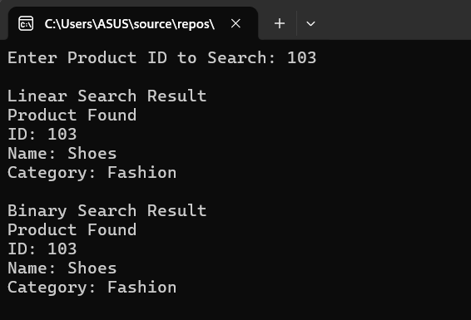
Exercise 7: Financial Forecasting
Program.cs:-
using System;

class Program
{
// Recursive method to calculate future value
static double FutureValue(double currentValue, double growthRate, int years)
{
// Base case
if (years == 0)
return currentValue;

// Recursive call
return FutureValue(currentValue * (1 + growthRate / 100), growthRate, years - 1);
}

static void Main(string[] args)
{
Console.Write("Enter Current Value: ");
double currentValue = Convert.ToDouble(Console.ReadLine());

Console.Write("Enter Annual Growth Rate (%): ");
double growthRate = Convert.ToDouble(Console.ReadLine());

Console.Write("Enter Number of Years: ");
int years = Convert.ToInt32(Console.ReadLine());

double futureValue = FutureValue(currentValue, growthRate, years);

Console.WriteLine("\nPredicted Future Value = " + futureValue);

Console.ReadKey();
}
}
Output:-
